**Architecture and Design**

**laboratory work 8**

**EXERCISE 01 – Creating UML diagrams**

**IMPORTANT: PERFORM ALL TASKS ACCORDING TO YOUR OWN TOPIC.**

# **Overview**

In this project, you will finish initial design of your project by graphically representing deployment diagram, which is used in deployment step.

WEB Tutorial:

<https://www.edrawsoft.com/deployment-chart-example.html>

<https://www.edrawmax.com/article/deployment-diagram-examples.html>

<https://creately.com/blog/diagrams/deployment-diagram-tutorial/>

To successfully complete this exercise, you must:

1. Create a Deployment Diagram, which describes the physical deployment of information generated by the software program on hardware components.
   * 1. Define main objects, files and devices in your system and classify them according to standards of a Deployment Diagram.

* Artifacts are mapping components to physical elements. A product developed by the software, symbolized by a rectangle with the name and the word “artifact” enclosed by double arrows. Examples of artifacts include model files, source files, scripts, and binary executable files, a table in a database system, a development deliverable, or a word-processing document, a mail message.

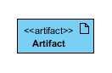

* Association: A line that indicates a message or other type of communication between nodes. An association represents a communication path between nodes.

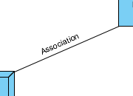

* Components are logical element structures, which is represented by a rectangle with two tabs that indicates a software element.

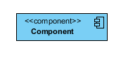

* Dependency: A dashed line that ends in an arrow, which indicates that one node or component is dependent on another.

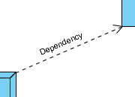

* Interface: A circle that indicates a contractual relationship. Those objects that realize the interface must complete some sort of obligation.



* Node: A hardware component (computer, server, hard drive, server software, routers, switches, firewalls), shown by a three-dimensional box.

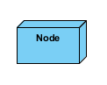

* Node as container: A node that contains another node inside of it—such as in the example below, where the nodes contain components. The following diagram shows a deployment diagram for part of an embedded system, depicting an executable artifact as being contained by the motherboard node.

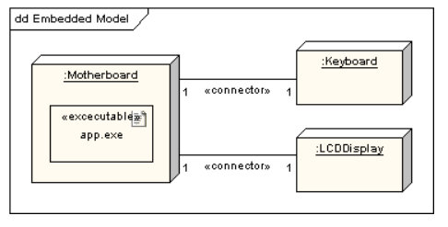

* + 1. Next, using these elements create a Deployment Diagaram.
    2. Save your diagram and upload it on DL.

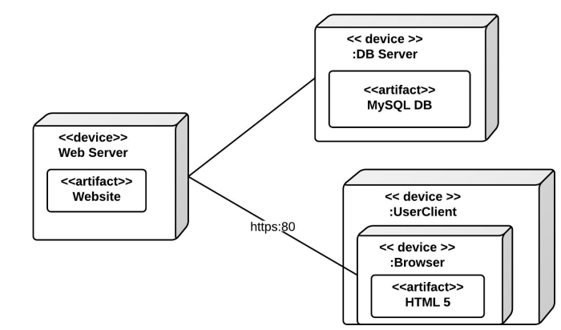

Pic. 1 – An example of Deployment Diagram

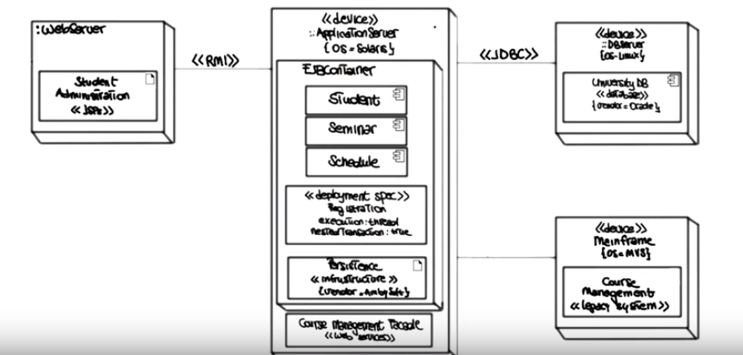

Pic. 2 – An another example of a Deployment Diagram